One Flew Over the Cuckoo’s Nest
This is an academy award winning movie from 1975. (Look for young Jack Nicholson, Danny DeVito, Christopher Lloyd…) It is based on Ken Kesey’s novel of the same name. The movie contains coarse language, but it is language you would expect from individuals in their situation.

After we finish the movie, you and a partner will choose a psychologist from the list below. You will be responsible for analyzing the film from your psychologist’s point of view. This should include findings from their studies, extensions of the studies from the perspective with which they are associated, how they would critique/criticize the events of the movie, etc.

You will create a presentation and lead a discussion that will review the key information about your assigned individual as well as the connections to the movie itself. We will meet in the media center for one day to prepare.

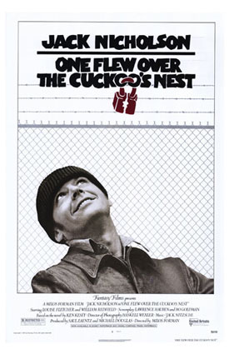
Groups:
- Watson/Skinner (Behaviorism)
- Bandura (Observational Learning)
- Festinger (Cognitive Dissonance)
- Rotter (Locus of Control)
- Kohlberg (Morality)
- Freud (Psychoanalysis)
- Langer & Rodin (The effects of choice and enhanced personal responsibility)
- Asch (Conformity)
- Milgram (Obedience)
- Zimbardo (Social roles)
- Darley & Latane (Bystander Effect)
- Sherif (Reducing Prejudice)

Rubric
Criterion | Details | Possible Points | Actual Points | Comments
Content | The major theories of the psychologists and their studies were correctly reviewed and discussed: including the perspective and important assumptions from that perspective, methods of research, results of the study(ies), criticisms of the study(ies). | 25
Links to the Movie | Connections to the movie were appropriate and insightful. | 15
Participation | All group members participated and presented AND encouraged participation from classmates. | 5
Attentiveness | All group members listened to AND participated during the other groups. | 5
 | TOTAL | 50

